GTB  
  
**QA**  
[DEV 21.07] OT-1188 | XT | PT | BP | BP Summary S2D Popup (Kuga)

**Jira ticket:**  
<https://jira.uhub.biz/browse/GTBEMEAOPT-1188>

**Site**  
<https://www.ford.pt/>

**Test location**  
Kuga NGC Summary Page (any configuration)

**Test Description**  
View the QA Link. In the top right corner click on “Configurador”. Once loaded, select the “Novo Kuga”. You are now in the NGC build and price journey, make your way through the journey selecting any options. Once you have hit the Summary page, see screenshots. Wait 10 seconds and a popup will appear.  
  
The Popup can only appear once every 15 minutes, up to a maximum of 3 times.  
The Popup can only appear on the Summary page of the Kuga.

The link on the popin will open in a new tab.  
 **Browser:**   
All  
  
**Device:**   
All  
  
**Audience rules:**   
All

**QA Links:**

[**https://www.ford.pt/?at_preview_token=Lgqbe4bXT9ftYHPZF3Fzhg&at_preview_index=1_1&at_preview_listed_activities_only=true**](https://www.ford.pt/?at_preview_token=Lgqbe4bXT9ftYHPZF3Fzhg&at_preview_index=1_1&at_preview_listed_activities_only=true)

**Popup: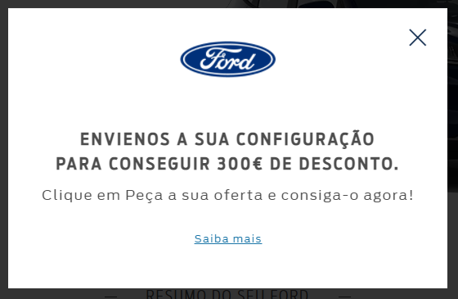 Summary Page:**